Batch: C3 Roll No.: 16010123217

Experiment No. 6

Grade: AA / AB / BB / BC / CC / CD /DD

Signature of the Staff In-charge with date

Title: Study, Implementation and Analysis of All Pair Shortest Path.
Objective To learn the All-Pair Shortest Path using Floyd-Warshall’s algorithm
CO to be achieved:
CO 2 | Describe various algorithm design strategies to solve different problems and analyse Complexity.
Books/ Journals/ Websites referred:
- Ellis horowitz, Sarataj Sahni, S.Rajsekaran,” Fundamentals of computer algorithm”, University Press
- T.H.Cormen ,C.E.Leiserson,R.L.Rivest and C.Stein,” Introduction to algortihtms”,2nd Edition ,MIT press/McGraw Hill,2001
- http://users.cecs.anu.edu.au/~Alistair.Rendell/Teaching/apac_comp3600/module4/all_pairs_shortest_paths.xhtml
- https://www.geeksforgeeks.org/floyd-warshall-algorithm-dp-16/
- http://www.cs.bilkent.edu.tr/~atat/502/AllPairsSP.ppt
Theory:
It aims to figure out the shortest path from each vertex v to every other u.
- In all pair shortest path, when a weighted graph is represented by its weight matrix W then objective is to find the distance between every pair of nodes.
- Apply dynamic programming to solve the all pairs shortest path.
- In all pair shortest path algorithm, we first decomposed the given problem into sub problems.
- In this principle of optimally is used for solving the problem.
- It means any sub path of shortest path is a shortest path between the end nodes.

Algorithm:
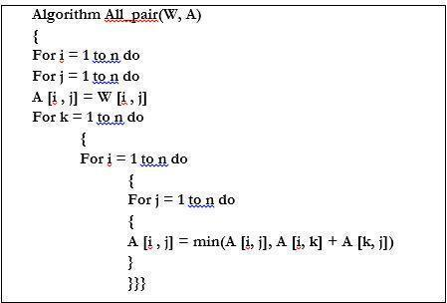
Example :
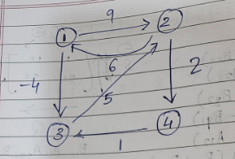

Solution for the example:

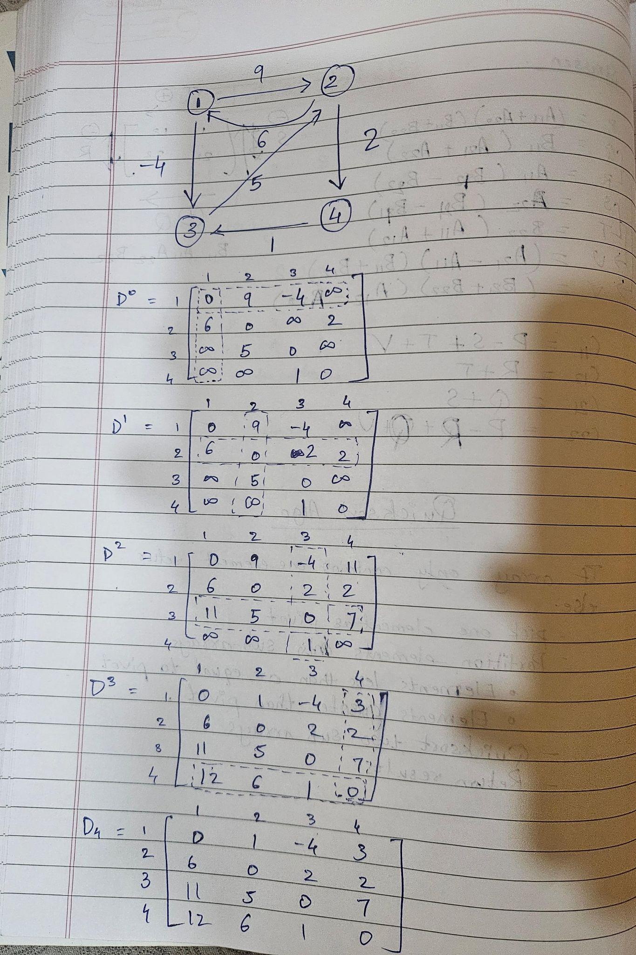

Code:
#include <bits/stdc++.h>
using namespace std;
#define int long long
#define endl "\n"

const int MOD = 1e9 + 7;
const int INF = LLONG_MAX >> 1;

signed main(){

int n, m;
cout<<"Enter the number of vertices:\t";
cin>>n;
cout<<"Enter the number of edges:\t";
cin>>m;
vector<vector<int>> adjmat(n, vector<int>(n, INF));
for(int i = 0; i < n; i++){
adjmat[i][i] = 0;
}
cout<<"Enter the edges and their distance"<<endl;
for(int i = 0; i<m; i++){
int u,v,w;
cin>>u>>v>>w;
u--; v--;
adjmat[u][v] = w;
}

for(int k = 0; k<n; k++){
for(int i = 0; i<n; i++){
for(int j = 0; j<n; j++){
adjmat[i][j] = min(adjmat[i][j], adjmat[i][k]+adjmat[k][j]);
}
}
}

cout<<"\nShortest Pairs Matrix"<<endl;
for(int i = 0; i<n; i++){
for(int j = 0; j<n; j++){
if(adjmat[i][j] == INF) cout<<"INF";
else cout<<adjmat[i][j]<<" ";
}
cout<<endl;
}

return 0;
}

Output:
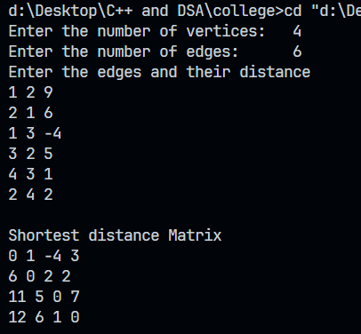

Analysis of algorithm:

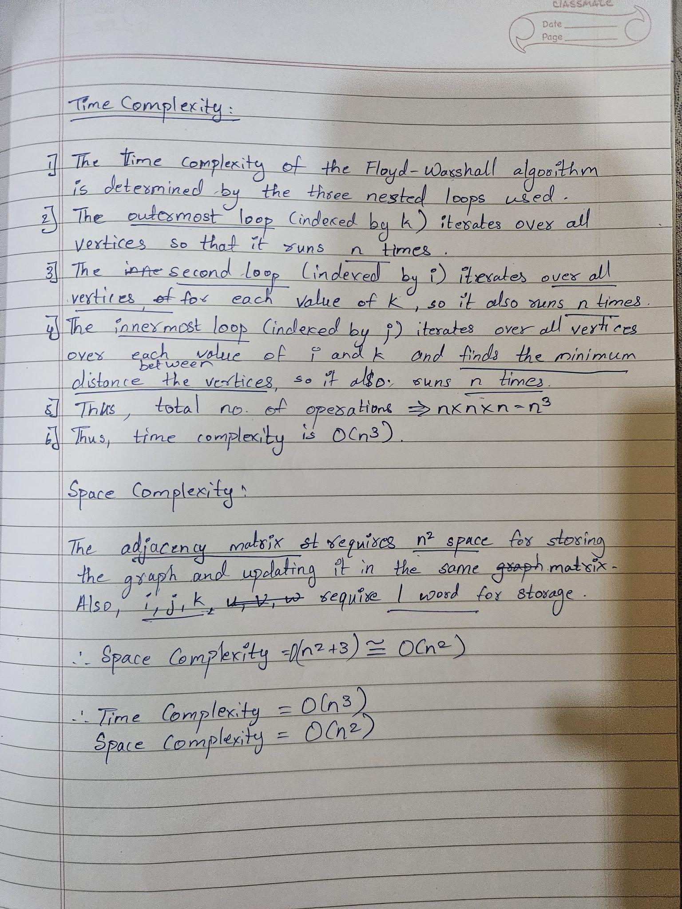

CONCLUSION:

From this experiment we learnt about the Floyd Warshall Algorithm to find the all shortest pairs. We also learnt about the drawback of the dijkstra algorithm (negative values) and how it was overcome by using Floyd Warshall algorithm. This algorithm might be slow than dijkstra algorithm but it overcome its drawback providing a better solution than dijkstra algorithm

